ANALYSIS REPORT ON COVID-19 TREATMENT AND LOCATIONS

INTRODUCTION

The dataset is for the analysis on Covid-19 treatment site and locations, the clinics and pharmacies that render these treatments. The data set used in this analysis contains information about :Provider Name, Address, City, State, Zip, Latitude, Longitude, Geopoint, Last report date, Is PAP Site, Is Telehealth Site, Pharmacist Prescribing, Home delivery, Is T2T Site, Is ICATT Site, Has USG Product, Has Paxlovid, Has Commercial Paxlovid, Has USG Paxlovid, Has Lagevrio, Has Commercial Lagevrio, Has USG Lagevrio, Has Veklury, Grantee Code, and Provider Note.

**ABOUT THE DATA/DATA COLLECTION**

This data is a structured and a secondary collected data. The data contains a table in csv files. It contains 65729 rows and 26 columns.

The analysis to be carried out is to answer the following questions;

1. Which cities have USG Products?
2. Which Provider Name has Paxlovid?
3. Which Pharmacies are prescribing Commercial Products?
4. Which cities has Telehealth Site?
5. Which cities have PAP Site?

**TOOLS**

The tool used is Microsoft Power BI for analysis and Power Query for data cleaning.

**DATA CLEANING AND TRANSFORMATION**

The following are the different cleaning procedures;

* Checked for duplicates and blanks.

**EXPLORATORY DATA ANALYSIS AND INSIGHT**

For the analysis to be understood and the questions to be answered, pivot tables were created for proper analyzation and insights. Below are the answers to each question, its analysis and insights;

1. Which cities have USG Products?

The city and Has USG product were filtered in order to find out the cities which have USG Products available to them. Analysis shows that less than 1% of all the cities in South America and North America has USG products.

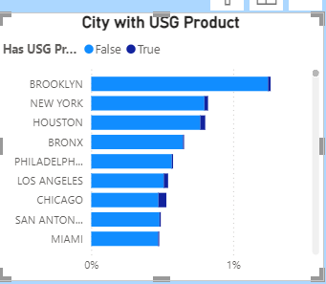

A Stacked bar chart was used to show the Cities with USG Products.

1. Which Provider Name has Paxlovid?

In order to find out the provider name with paxlovid, the provide name and Has paxlovid were filtered out. Data shows that HEB pharmacy, Giant pharmacy, Stop & Shop pharmacy were the top 3 provider name with paxlovid.

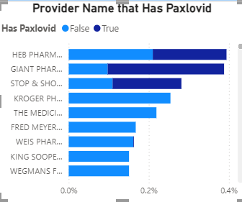

A Stacked bar chart was used to show the Provider Name with Paxlovid.

1. Which Pharmacist are prescribing Commercial products?

The Pharmacist prescribing and Commercial products were filtered out to know which pharmacist are prescribing commercial products. Analysis shows that only 0.70% pharmacist prescribes commercial products, the remaining 99.30% of pharmacist do not prescribe commercial products.

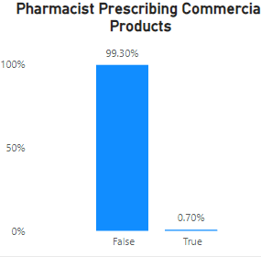

A stacked column chart was used to show the Pharmacist prescribing Commercial products.

1. Which cities have Telehealth Site?

To find out the cities where telehealth sites are available, City (longitude and latitude) and Is Telehealth Site were filtered. Data shows that less than 1% of the cities is a telehealth site.

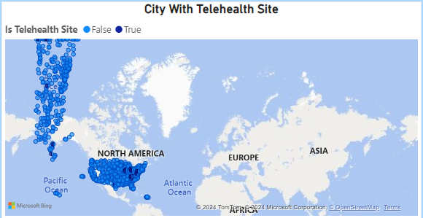

A map was used to show the cities which are used as telehealth site.

1. Which cities have PAP Site?

In order to know the cities which are used as PAP site, the City and Is PAP Site was filtered. Analysis shows that about 95% of the city is PAP Site.

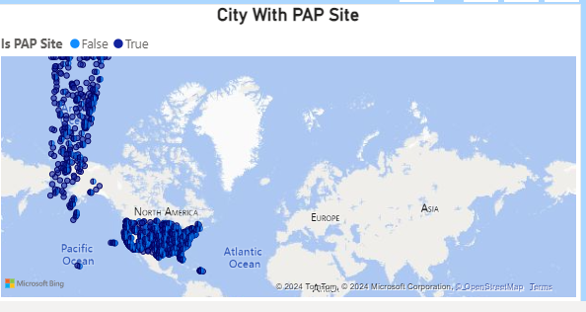

A map was used to show the cities which are used as PAP Site.